NEW CATALOG

> Problem Statement:

The captions and messages, which we call "dictionary", used in our products
are now in state of confusion.

There're so many products, for example HR series has 3 products,
that is, CJK, CWS and CSR, and each product has their own way
to manage the captions and messages. That means each product
has their own database table, and each has different key columns.
And adding to that, lack of sufficient communication with each other
caused the situation that some "dictionaries"are slight different
between the products.

And what is worse, WAP has been heading for global market and
each product separatedly tried to translate their "dictionaries"
in some way. Some products decided to asked a company to translate
their "dictionaries", other products tried to translate their "dictionaries"
on their own, using developers who know the product well.

Against this confused state, we wants you:
- to unify each "dictionaries"
- make it easy for everyone in every department(**) to use "dictionary" data

(**) e.g. sales, consultants and of course development departments

[Constraints]
Server-side programming language: Java (You can use OSS libraries like Spring)
Database: Oracle

> Solution:

The solution for this problem is to unify the dictionary tables into a single database and provide a common method of access (Mainly to add data), so that the translator can access the database via that interface and add he can data efficiently. We will also provide him a suggestion from google translate and previously translated data. A direct email will be sent to the translator of the particular language of a table if the new entry is added or some data is modified.

> Why do we need this solution :

- We do not have a common platform that have all of the tables from all of the departments.
- As tables from different products can be present in different formats. Like .dat or .csv
- The different languages version of various tables are scattered that uses more memory and makes database structure complicated.
- When translator wants to add a data, he might add the data as per his own thinking. So the same translated data can be present in many forms because different translators can have different thinking about the data to be translated. So there is the inconsistency in can be present as same data can be translated into different forms. Example If someone has to translate the data in Hindi that is रोक into English so there can be two option as STOP and BAN. If the different translators use both of them then is problem.
- There was no any solution for contacting the different translators related to table if some changes are to be done in some language as same changes should be done in other language.

> How we can do it:->

- The basic idea to reduce memory requirement by each dictionary table is to reduce the redundancy by storing the caption columns only once for all languages. This will solve the problem of unifying the data and the problem of different format of input.
- The common interface will provide efficient access to all the tables.
- The problem of inconsistency can be solved by providing two types of suggestions list. The first will be dependent on the previously translated data and this will show the translated strings that has should be used for sub-string in input and the number of times it is used. So the translator will know that this input substring has been translated into this string for specific number of times and he may choose the one from these suggestions that is used maximum number of times. And when the previously translated suggestion list do not have sufficient suggestion or any suggestion, we can show suggestions from google translate so that translator can get various ideas about the text to be translated and this can help him to do it faster.
- When any new table is added or new row is added or some data is updated, we will have to notify the particular language translator related to that table. So we can do this by email directly. Because translator or any other person tends to open his email often.

> System platform:

The system will be deployed as web service.
When user performs any operation, the system will exchange data with the server. The Server will contain a single unified database containing all the dictionaries.

> Requirements of the system:

    - A server with some space: The system will require a server with space proportional to the number of dictionaries and their translation dictionaries available.
    - A local system with network connection : The user would need a local system with internet connection, so that the system can exchange data with the server.
    - The Google apis: An active account to use Google translate apis to show translator suggestions.

> How we guaranty the correctness of our system :

After finishing each module of our system, we will write tests for the respective module, to check if it works fine. We will also write tests to ensure that this module doesn't affect the other modules.

After we develop the complete system, we will write tests for the whole system. We will follow the method of regression testing, to ensure that the changes that we include to fix the current bug, doesn't introduce new bugs.

The current dictionary database management team will also be consulted to ensure the correctness of our system.

> Speed of the system:

The suggestion algorithm from previous translated data can be very time and resource consuming, so we will have to implement the fastest data-structure to provide this feature. But because of this feature the speed of translation will increase as translator will be helped by many suggestions.

FUNCTIONS:

1.) AddDictionaryTable (Priority : high)

Operation:

a. This is the important function in our project.
b. Only the dictionary database managers and project developers related to dictionary, having the knowledge of dictionary will be able to add this table in our database. We will also maintain the metadata that will contain the information about all the table as one row per table .
c. We will initially ask user the various parameters as follows and these will added to a metedata table in tuple corresponding to current table:
        - Table name
        - Table Description
        - No. of caption columns
        - No. of messages columns
        - product description
        - The actual text column
        - The actual translation column
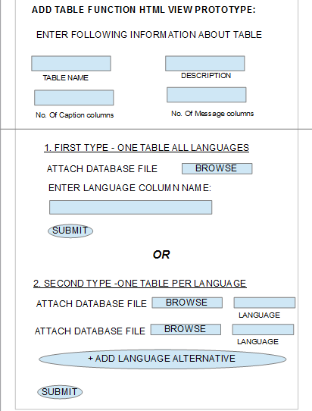

d. We will ask user if there are language alternatives are present as different tables or in same table.
e. We will ask user the language column name or number if the language alternatives of table are present in same table.
f. And if user selects that they are present in different table then we will ask him to input the different language tables files as we will provide him an option to add a new language table and we will also ask him the respective language in which table is present.
g. If the user selects option of language alternatives of table are present in same table, we can identify the different languages by language column name or number. Then we will simply add the number of set of message columns equal to number of languages and copy the language message attribute values to these respective column set from the rows. After this we delete all the rows that has been copied, below the first language.
h. If the user selects option that language alternatives are present in different table then we will simply add the number of set of message columns equal to number of languages and copy the language message attribute values to these respective column set from the respective tables.
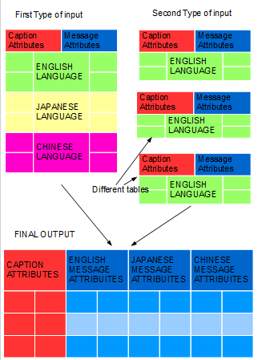
i. After doing the above procedure the message attributes values that belonged to different languages will be stored as new set of columns and and the a new table will be formed with single set of caption attribute values and many sets of message attribute values corresponding to different languages. We will keep track of the language sequences in which message attributes are stored by an multivalued attribute in metedata table.

j. We will also maintain a list of specific language translators mail address related to this table being added, so to notify them about the some future changes.

k. We will also maintain a table per language that will simply consist of text and their translations only. This table will contain all of text-translation from all the tables in our system for particular language. We will call it as 'text-translation' table. This table will be useful for getting suggestion from previously translated text.

Merits:

- The main advantage of this technique is that it is saving the space as the caption attribute values are not repeating for every language translation. Initially this thing was making the database size bigger and obviously as size increases the memory management and accessing data by searching gets more difficult and time taking.
- The structure of the dictionary table gets more systematic and simplified. As we can manage all the translations in a single table and do not need many tables for them.

2.) AddNewTranslation (Priority : high)

Operation:

    - Translator will be conveyed by an email that a new table is added or new entry is added or a some value is updated. So that the he can access that table and add the corresponding translations as per his language.
    - There are many cases possible here, first can be if the translator can not get the any suggestion from the suggestions from previously translated text because the text that he is trying to translate or the substrings of it are not present in suggestions from previously translated text. Then he will have to take help of google translate suggestions. Once he is done with translation we will call the update the previously translated suggestion data-structure.
    - Second can be, if he gets the list of suggestion from the previously translated text and he doesnt feel like they are sufficient he can take google suggestion into consideration.
    - Third if he gets suggestion from the from the previously translated text and he feels that they can be used, so he may select the most used suggestion as we will also provide him the number which denotes the number of times that suggestion is used.

Merits:

- This method will help the translator to translate more easily with the help of suggestion, So his speed will increase.
- The main advantage of this method will be to keep all the translations integrated. So that the different version of the same words will not appear so the translations will be consistent.

SUBFUNCTIONS -

A. FetchSuggestions – this function will be used to retrieve suggestion from maintained data-structure. This Data-structure will be created and maintained from the text-translation table that we have created earlier. This data-structure will be very fast and will have structure similar to TRIE or TST.

B. UpdateSuggestion – This function will be used whenever we add some new tables or new entries. We will definitely require to update a data-structure that provides suggestion.

MERITS – we can create a new system that enables company to translate the data by themselves. There is no need to give it to some other translation company. This will save lot of money. And may be a new service can be launched to translate the the products of other companies.

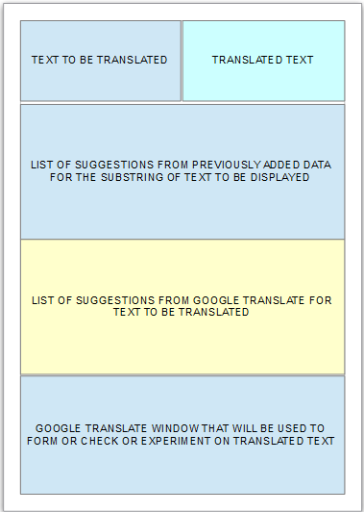

2.) UpdateTables (Priority : high)

Operation:

    - The translator or the guy that check this translation need to update the the table with the table like he may edit some translations or he can add a new entry or delete a new entry.
    - So if the this user changes a attribute values that is the text part of the original language then the mail will be sent to the translators of other languages to make the respective changes in that table and update suggestion function will be called.
    - If the developer adds a new entry in this database all the language translators will be notified and update suggestion function will be called.
    - If Some row will be deleted by then update suggestion function will be called.

Merits:

- So all the tables can be updated in synchronised manner with developers and translators.
- The data structure will be update simultaneously.

2.) SearchTables (Priority : medium)

Operation:

    - we will definitely need to search the table in which we will be operating.
    - By assuming that we know the department and the product in which the currently logged user is present, so we can show him all the table list with their description that are present in for that product and he will select one of them.
    - Example – if the some table contains the translation of the login screen so it will have its description as this table contains the translations about the login screen elements.
    - If he wants to access the table of some other product we will provide him the search feature like keyword-description search for product name, table-name for that.

* Future Work:

- In future if time permits we can create such an algorithm to automate whole system to translate whole text based on both suggestion by itself.
- If the other department translator or developer wants to merge edit or merge two table we can create an interactive tool which can do this without al technical knowledge.

Thank you
Shubham Satish Baldava
Works Applications Co. Ltd.
COMPANY Web Service
Software Engineering Interns

